Freshmen Summer Internship Program 2013

Assignment 3

**Topic Drivetrain**

* Feel free to approach any senior any time of the day – for queries, doubts or trash talk; we are always open.
* Don’t forget to list the references at the end of your assignment
* Keep in mind that an image is worth thousand words
* Enjoy your assignment!!

Submission deadline – 11:59 PM, 24/5/2013

**Section A - DRIVETRAIN (Basic)**

1. Find out the functions and specific application of the commonly used bearings; namely *ball bearing, angular contact bearing, cylindrical roller bearing, tapered roller bearing* and *needle roller bearing*. List down the basic difference in the geometry which allows each one to bear **the loads it is supposed to**.
2. What are the types of gears used in the EV02 gearbox? What are the advantages, disadvantages and application of *spur, helical and bevel* gears?
3. **Planetary Gearbox**. Try to find out why is Drivetrain sub-system here, at IITB Racing is so obsessed with planetary gearboxes from last 2 years. List all the possible advantages and disadvantages you can find as well as think of.   
   Now derive all possible gear set ratios you can think of.   
   You may like to go through this link: <http://science.howstuffworks.com/transport/engines-equipment/gear7.htm>
4. **Universal Joint.** This mechanism was described in *Technica curiosa sive mirabilia artis* (1664) by Gaspar Schott, but mistakenly claimed that it was a constant-velocity joint. Afterwards, between 1667 and 1675, Robert Hooke analyzed the joint and found that its speed of rotation was non-uniform.   
   Now you get to be the Robert Hooke and prove that you are right by deriving the equation relating the angular velocities of the two shafts of a simple universal joint.

**Section B - DRIVETRAIN (Advanced)**

1. **Power calculation**: There is a very critical relation between mass of the car, endurance track and power required by a car (energy per unit time).  
   This summer we are going to start designing the next year car, Evo3. Our first step should be deciding a feasible weight of the car, and using the endurance track data, calculating the energy required by the car.  
   Now, all you have to do is a simple power calculation for different value of reduction ratio.  
   Let’s proceed with these steps:   
   Choose a feasible mass of the car. (Assume 320 kg, with driver)  
   Given   
   the track dimensions  
   efficiency of transmission =1(assume single step reduction)

radius of wheel= 10 inches  
maximum velocity at turns (steady turn) = µRg (µ= 1.4)  
max braking and acceleration as –2g and 2g (g = 9.8m/s2)  
 max torque and RPM by motor= 6000RPM  
assume drag force, Fresistance= (0.35*v2) N (v is in m/s)  
calculate the time required to complete the endurance for two values of reduction ratio(6.1 and 6.3). For each of the values, calculate the total energy required.  
Use matlab for calculations.  
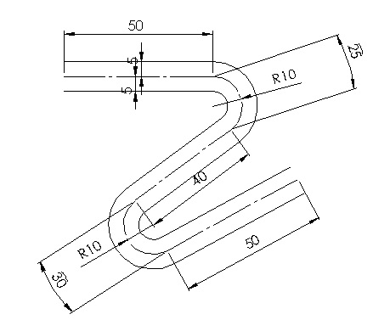**Endurance track**

We will discuss the concept in the session.